Open loop has uncontrollable output. This can lead to 100,000x times bigger side of output.
Saturation can cause distortion in signal and has advantages and disadvantages.

In order to make an open loop to closed, we connect negative terminal to output called feedback loop. This allows to control the output going into the input through resistor

Cut off voltage: The maximum voltage that can be obtained by the output
Gain = -4
S.No | Vin | Vout (Expected) | Vout (observed)
1. | 2 | -8 | -10.47
2. | 3 | -12 | -11.04
3. | 4 | -12 | -11.3

S.No | Vin | Rf | Rin | Gain | Vout (Expected) | Vout (observed)
1. | 1 | 50 | 10 | -5 | -5 | -6.31
2. | 1 | 100 | 10 | -10 | -10 | -10.97
3. | 1 | 48 | 4 | -12 | -12 | -11.17

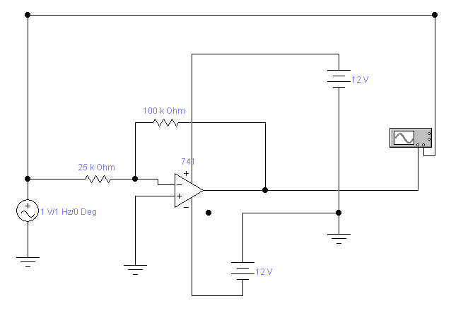
INVERTING

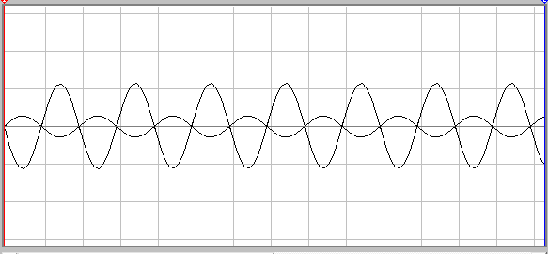

Non-Inverting:
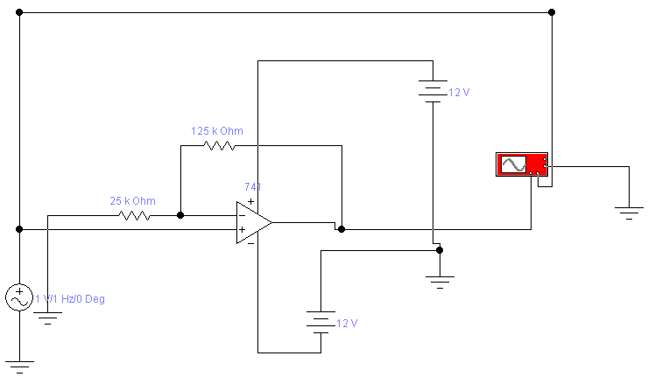Graph
